**Dear Parent / Learner**

# FITNESS CHALLENGE 2022

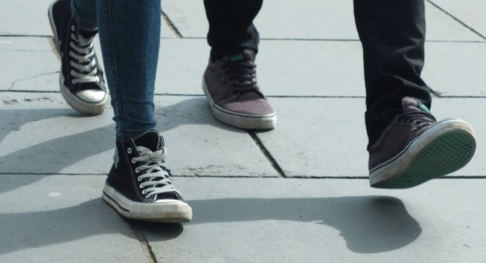

**This year is the first year of the rest of our lives.**

Let’s do things differently this time around, starting from now. If the mountain will not come to us, we will go to the mountain. Let's boot up, put our best foot forward, and decide once for all to GET FIT!

Academically we’re on track. Thanks to – or perhaps in spite of – the Covid crisis, we have learned over the past months and years to knuckle down and get the ***head*** stuff done, independently and online and bringing all our ingenuity and talents to bear.

BUT ... it’s now time to spread our wings a little further, so to speak, to dust off our footgear and miscellaneous other get-fit stuff lying forgotten in the cupboard, and to pay a little more than lip service to the golden saying:

**Mens Sana In Corpore Sano  
A Healthy Mind In A Healthy Body**

It’s time for us to get together again in the parks and on the walkways and in the open fields, and to do for our bodies what we have been doing for our minds – bringing them to a state good health and fitness for the purpose for which they were designed.

Our audience is wide: we embark on this initiative for ourselves, for our children, and for the broader community of which we are a part. In the remainder of this letter we outline our basic plan for the way ahead, some of the details of what we have in mind – the practicalities of *where*, when, how, and *how much* and . . .

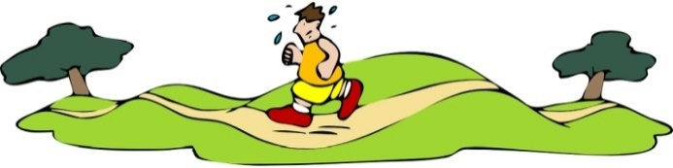

# Background

The need for an initiative such as this became apparent during the weekly PT / exercise sessions conducted by the ***head*** of the Sports Department. The instructors have reported a marked decline in average fitness levels in both boys and girls, compared to just a few years ago: most of the boys could not manage two laps of the sports field without becoming seriously out of breath; and the girls did not fare much better when put through their paces.

So the idea came to be bandied about – why not put together some kind of routine that would combine the aspects of FUN, SOCIAL and EXERCISING?

To employ a homely metaphor: If a diet of exercise could in some way be lightened with ladles of fun and generous doses of social exchange, what more could one hope to achieve? And if the nutritional advantages could in some way be extended to and impressed upon peers, parents and others – the community in general – then we might be preparing for a banquet indeed! Provided that all the right guidelines are followed, we can head off all the negative consequences of lack of activity, and welcome all the positive benefits instead!

And so the idea of **Fitness Challenge 2022** was born. We will meet together as a sort of extended family twice a week, say on Wednesdays and Saturdays: a group of like-minded people in pursuit of a common goal, guided and fired by the 3-pronged approach outlined above.

## General Benefits

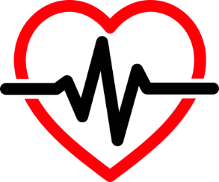The general benefits of exercise – both physical and mental – are too well known to require elaborate justification. To recap and consolidate, regular exercise can result in each of the following:

* A stronger body generally
* A stronger cardio-vascular system
* An improved sleep pattern
* An improved concentration
* An increased self-confidence  
  🡪 the main ingredient for ‘taking on the world’

## Losing Weight

An important focus area that became apparent during initial discussions relates to that OTHER control are inseparable, but they need to be considered in their own respective rights, because physical appearance is often the only physical *evidence*, to the observer, of the state of physical fitness of the person concerned.

It would be a very boring world indeed if everyone were built the same – matchbox clones with identical height and girth – to say nothing of other alignments and preferences. Mercifully, we are all quite different in most respects, and it is perfectly OK for no two people on Earth to have exactly the same weight.

**Did You Know ?????**

The term ‘weight’ is a misnomer. It has to do with gravity. On the Moon, a person would have an identical mass, but would weigh six times less than on Earth!

A person’s age and gender are obvious determinants. The other natural factor that must be taken into account in determining a person’s optimal or ‘acceptable’ weight, is their *height*.

Enter the concept of BMI, or Body Mass Index. This is a measure of a person’s body fat, based on their height and weight. It applies to adult men and women, i.e. over the age of about 18. It is measured by dividing a person's weight in kilograms by the square of their height in meters. A HIGH BMI (OVER ABOUT 25) indicates overweightness tending to obesity, just as a low BMI (less than about 18.5) indicates thinness tending to emaciation. Both of these extremes are naturally undesirable.

Healthy BMI range: 18.5 - 25 kg/m2

The table below gives a breakdown of the different BMI ranges that correspond with the categories of ‘thin’, ‘normal’, ‘overweight’ and ‘obese’. Of interest is the column on the right, which shows the number of entrants in each category, that have recently signed up for **Fitness Challenge 2022**.

|  |  |  |  |
| --- | --- | --- | --- |
|  | **Category** | **BMI range** | **Entrants** |
| **Fitness Challenge 2022** | Severe Thinness | < 15.9 | 0 |
| Moderate Thinness | 16 – 16.9 | 0 |
| Mild Thinness | 17 – 18.4 | 2 |
| Normal | 18.5 – 24.9 | 23 |
| Overweight | 25 – 29.9 | 25 |
| Obese Class I | 30 – 34.9 | 16 |
| Obese Class II | 35 – 39.9 | 0 |
| Obese Class III | > 40 | 0 |
|  | **Total number of entrants** | |  |

# The Rubber Meets The Road

Down to business. While a number of people – learners, parents and community members – have already signed up for **Fitness Challenge 2022**, our ultimate goal is to get the entire school on board in one way or another – whether by actively taking part in one of the events, or by providing much needed support (see below), or by participating in one of the administrative or fund-raising capacities, or even by just showing up along one of the routes and providing spectator support.

## Signing Up

So how does one go about signing up for **Fitness Challenge 2022**? It’s really as easy as A–B–C:

* Determine your specific area of involvement – participator, supporter, fund-raiser. This is frequently the most difficult part.
* Download the Entry Form from the school’s website.
* Submit the completed Entry Form to the Sports Coordinator, electronically or via email.

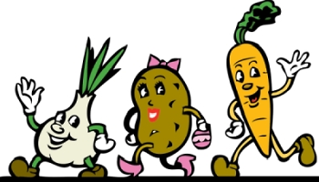

All shapes and sizes are welcome. You can even wear PINK shoes and a bow 😊

## Footgear

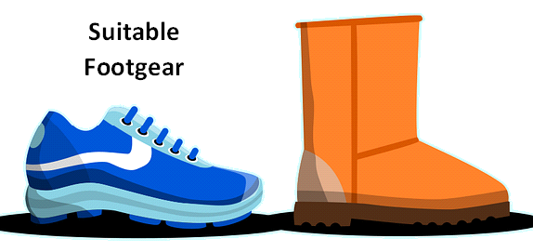A bad workman blames his tools. The converse is also true: every successful practitioner – in whatever field – will have high praise for the tools (gear) which helped him to achieve success. In the world of walking / jogging / running, this inevitably comes down to the choice of footgear. The range of different options is quite staggering, with manufacturers releasing upgraded models at least once a year to keep up with the competition. Hundreds of sneakers come out over the course of a year, and determining the best and most suitable among them is no easy task.

## Categories

We are all built differently, and the differences matter; hence it makes perfect sense to categorise participants. An overweight 60 year old male cannot compete meaningfully against a 25 year old female who loves hiking and plays hockey twice a week. Competition with others may provide the stimulus or motivation for improvement, but it is our own inabilities and weaknesses that we are constantly striving to overcome.

|  |  |  |  |  |  |  |  |
| --- | --- | --- | --- | --- | --- | --- | --- |
| **Categories** | **Gender** | M | F |  |  |  |  |
| **Ability** | Very unfit | Unfit | Fit | Very fit |  |  |
| **Age** | Under 20 | 20–30 | 30–40 | 40–50 | 50–60 | Over 60 |

## Certificates

Goals achieved deserve some form of recognition. It has been suggested that we devise a scheme whereby participants can be rewarded for their commitment and hard work. The award of an appropriate certificate seems to be a good solution. Certificates are easy to devise, easy to print, easy on the eye – and can be framed both as pleasing reminders of the past and as powerful incentives for the future.

Name  
Surname

## Walking Tips

It would be remiss of us, in a brief of this nature, not to relay a few relevant tips on the right way to exercise. Since the majority of participants have opted for the walking option, we have decided to share with you the TEN most popular walking tips, as voted upon in a recent poll conducted by the Health and Wellness Institute. Here they are:

|  |  |
| --- | --- |
| **Top 10 Walking Tips** | **Votes** |
|  | 1102 |
|  | 892 |
|  | 879 |
|  | 876 |
|  | 852 |
|  | 851 |
|  | 849 |
|  | 841 |
|  | 837 |
|  | 814 |

# Volunteers

We would not be able to mount an undertaking of this magnitude and complexity without a lot of help. To be sure, nothing prevents the self-motivated exerciser from getting out there and getting things done, without any external input. But when it comes to co-ordinating large groups of people in organised events, and providing all the necessary support, backup and added extras – media exposure, photos, certificates, record-keeping, etc. – then we need to recruit some volunteers.

# Finances

Money makes the world go round. It also enables us to pay for certain professional services that we are considering engaging if required, such as nutrition experts, sports coaches, and even occupational therapists. We also envision printing costs (e.g. for certificates), and costs for hiring certain equipment, venues and other sporting facilities. Data processing and media services will be catered for in-house: fortunately, we have a very competent computer department.

## Cake Sales, etc.

Stock-in-trade fundraising enterprises include our ever-popular cake sales, usually hosted on Fridays during break times by Register Classes, on a rotational basis. If we do not make sufficient headway, we may extend this to things like car-washes and lucky draw competitions. There is no shortage of enterprising ideas when it comes to raising a few extra Rands in a good cause!

## Items to Purchase

Participants will be given the opportunity to purchase certain items from our school shop at slightly reduced rates. These items include a full range of customised T-shirts (all sizes, from S to XXL) and wristbands (which are useful for storing pertinent medical information such as blood group). Sales of all these items to date have been brisk, as the following table shows:

|  |  |  |
| --- | --- | --- |
| **Sale of Items – To Date** | | |
| **T-Shirts** | **Wristbands** | **TOTAL** |
| R1805.00 | R464.00 | R2269.00 |

# Closing

**Fitness Challenge 2022** is Excel High’s response to a very broad societal issue, often voiced but all too often ignored – the need to counterbalance our regimented sedentary lifestyle with an equally regimented path to fitness and health, that will hopefully one day transition naturally into the ‘new normal’ – the accepted way of life. We need to give our people a ***head*** start on health.

And so we embrace diversity, gladly acknowleging that with exercise, as with many things in life, one size does not fit all. Different fitness levels, abilities and ultimate goals dictate a customised approach, and we are happy to accommodate all the differences. Inclusivity trumps over the talented few. As someone once said, we don’t need a handful of people doing it perfectly, we need millions of people doing it imperfectly.

Yours in fitness of mind and body,

**G. Kroucamp**

**Excel High: Principal**

**Appendix: Supporting Staff And Professionals**

**Name, Sector, Position**

Fekisi R., Parent, Timekeeper

Nel F., Community, Tail-walker

Kleyhans K., Professional, Marshall

Oosthuizen B., Parent, Media

Du Preez C., Community, Photographer

Ngwenya L., Parent, Data

Melwa W., Parent, Marshall

Jacobs L., Professional, Timekeeper

Sirkhotte C., Community, Marshall

Asquith J., Parent, Marshall

Cohen W., Parent, Data

Doko L., Community, Media

Deerling Z., Parent, Tail-walker

Gilson C., Community, Photographer

Mbottana S., Parent, Timekeeper

Imrie W., Professional, Marshall

De Klerk T., Parent, Marshall

Beck K., Parent, Photographer

Bennet J., Parent, Tail-walker

Magwa D., Community, Data

Kanter Z., Parent, Timekeeper

Winter D., Parent, Marshall

Abrahams C., Community, Photographer

Chuang S., Professional, Marshall

Mackay C., Parent, Media

Mpongoshe K., Parent, Timekeeper

Sephten L., Community, Data

Bowren C., Parent, Marshall

Merchant N., Parent, Photographer

Kraus B., Community, Timekeeper

Fesi M., Community, Marshall

Moss B., Parent, Media

Ferreira K., Parent, Timekeeper

Zander M., Community, Data

Mtyhobo M., Community, Marshall

Heystek R., Parent, Photographer

Njokweni P., Parent, Marshall

Lentoor L., Professional, Tail-walker

Hageman M., Parent, Marshall